**Streams**

**Regina Rodriguez**

* **Stream 1**

Our problem involves books that have their titles, authors, and years of publication, and we want to display the titles of the books published after 1920.

First we created our Class “Books” with its attributes and constructors.

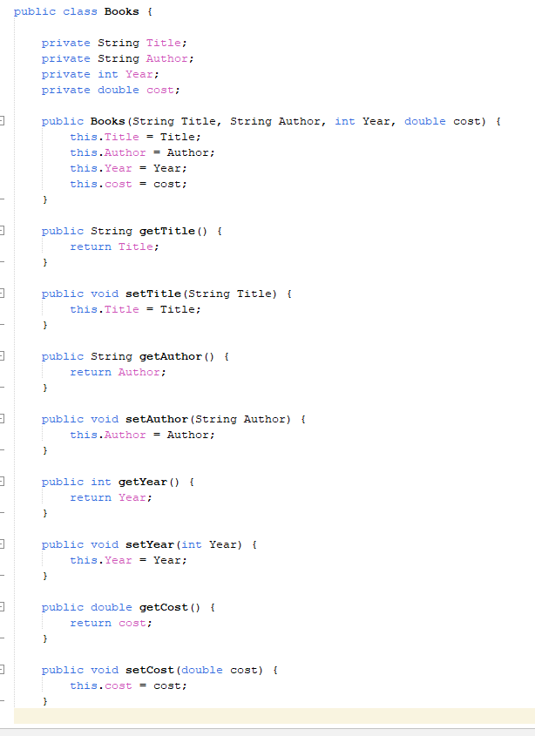

Creates our objects

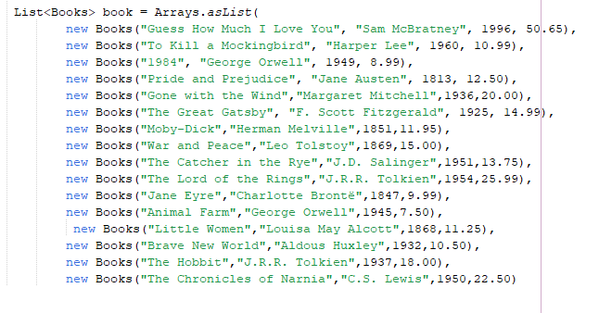

This are the steps that we have to follow to complete our problem

1. Filter the books published after 1920.
2. Sort the books by their year of publication in ascending order.
3. Map the results to include only the titles of each book.
4. Limit the results to the first 5 book titles.

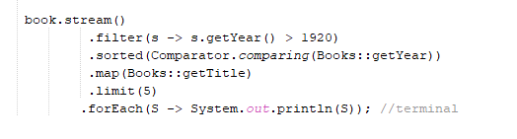

We create a stream of our books and use the filter method to ensure only books with publication years after 1920 are processed. Then we apply sorted to order the books from the oldest to the newest publication year. Next, we use map to extract only the book titles. Finally, we limit the results to the first 5 titles and use forEach to print each title.

Result:

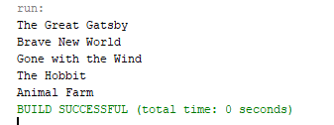

* **Stream 2**

Our problem involves managing a party business, and we need to identify events that will occur after a certain date and ensure that no event is repeated. We want to achieve this through four steps:

1. Sort the events by category.
2. Filter to only include events that occur after 2024/07/01.
3. Map the results to include only the category of each event.
4. Remove any duplicate events.

But first, we need to create our classes Events.

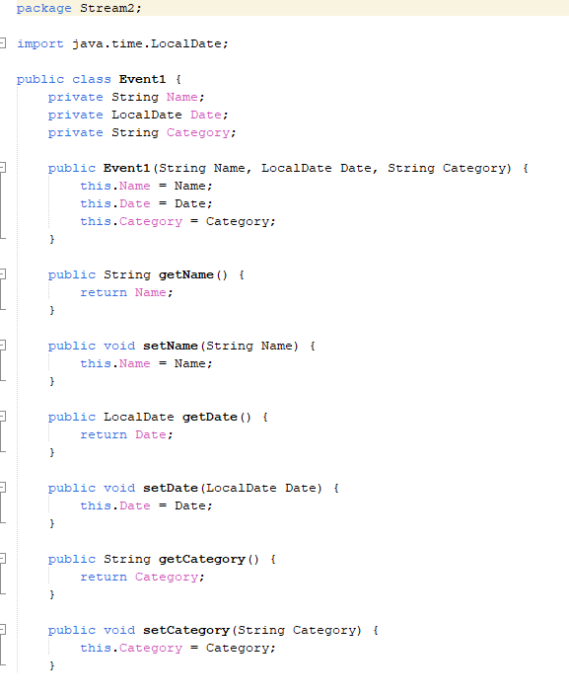

Creates our objects

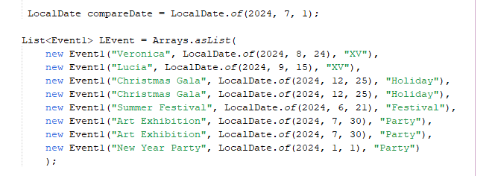

We create a stream of events, but first, we need to set up an attribute to limit the date we're interested in. After that, we use sorted to order the events by category in alphabetical order using ASCII values. Then we filter the events based on the date. Next, we use map to extract only the event categories, and finally, we remove any duplicate events. We use forEach to print out and view the most recent event categories.

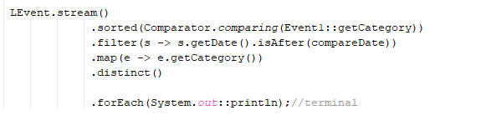

Result:

